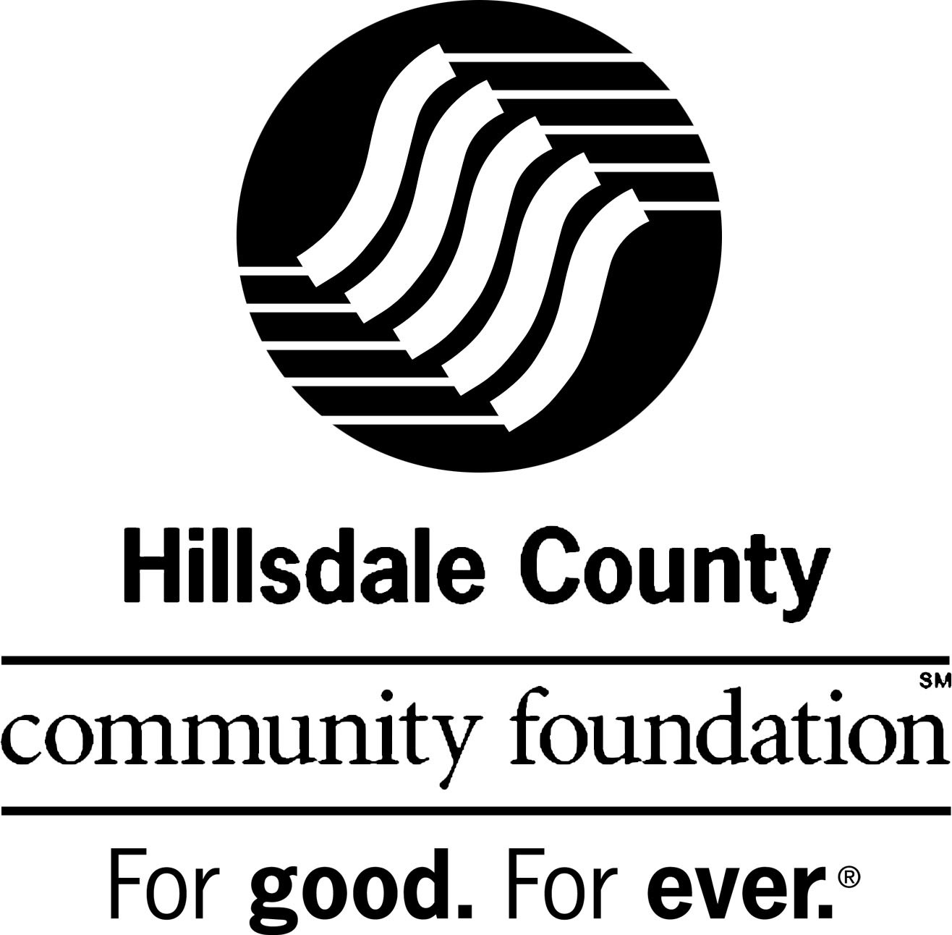

FOR IMMEDIATE RELEASE:

“The Great Give” Significantly Supports Local Non-Profits
Hillsdale, Michigan – November 29, 2018
Donors of Hillsdale County made the Hillsdale County Community Foundation’s Great Give an amazing success. Together, we showed how strong philanthropy can be. Community supporters came out in force, acting as financial champions for the nine local non-profit organizations on sight that day. More than $113,000 was leveraged, including public donations of $88,000 and bonus pool funds from the Community Foundation totaling $25,000.
The HCCF sponsored The Great Give, a Giving Day event aimed at encouraging all of Hillsdale County to give to local non-profits on November 27, which was recognized as Giving Tuesday, a global day dedicated to giving back. Families, individuals, and businesses came together for one common purpose: to celebrate generosity and to give. The spirit of philanthropy was widely demonstrated and celebrated in Hillsdale County.
During the Great Give many people made donations to nine local nonprofits, many of them providing critical assistance with local needs. There were opportunities for agencies to receive both random and assigned prizes and funds from the bonus pool. Online gifts were welcomed using the HCCF website, www.abouthccf.org, the HCCF Facebook page, and walk-in gifts were accepted at the HCCF office throughout the day. In total, 1405 contributions were received during the Great Give.
The day brought a number of new donors despite a lower amount of money raised from previous years. “We aren’t surprised by the lower amount of money raised this year”, said Sharon Bisher, HCCF President. “With the unstable market and the changes in the tax laws, we have seen trends of giving less. But they are still giving and we truly appreciate every one that has continued to give to all of these important agencies.”
The area non-profits that were directly involved in the Great Give are as follows: Alpha Omega, CAPA (Child Abuse Prevention and Awareness), Community Action Agency, Domestic Harmony, the Greater Hillsdale Humane Society, Hillsdale County Community Foundation, Hillsdale County Senior Services Center, Hospice of Hillsdale County, and St. Peter’s Free Clinic. The Hillsdale County Community Foundation sincerely thanks the community supporters who aided in furthering the mission of these organizations while maximizing the impact of their contributions during the Great Give event.
The Hillsdale County Community Foundation was established in 1991 “For good. For ever.” As a community grant-making foundation, it provides seed money to organizations and institutions that have identified problems and have designed constructive action programs aimed at solutions. A majority of the Foundation’s grant making is focused on the areas of youth, leadership, philanthropy and volunteerism.
#

Contact:
Sharon Bisher, President
Hillsdale County Community Foundation
517.439.5101, s.bisher@abouthccf.org
