Nondiscrimination Policy
Hillsdale County Community Foundation
(As of May 2017)

Employment
The Hillsdale County Community Foundation follows an equal opportunity employment policy and employs personnel without regard to race, creed, color, ethnicity, national origin, religion, sex, sexual orientation, gender expression, age, physical or mental ability, pregnancy, veteran status, military obligations, and marital status. This policy applies to hiring, internal promotions, training, opportunities for advancement, and terminations.
Grant Making
No person in the United States shall, on the basis of actual or perceived race, color, religion, national origin, sex, gender identity (as defined in paragraph 249(c)(4) of title 18, United States Code), sexual orientation, marital or parental status, political affiliation, military service, physical or mental ability, or any other improper criterion be excluded from participation in, be denied the benefits of, or be subjected to discrimination under any program or activity funded in whole or in part with funds made available by the community foundation, and any other program or activity funded in whole or in part with funds appropriated for grants, cooperative agreements, and other assistance administered by the community foundation.

Adopted by the Board of Directors: June 17, 2016

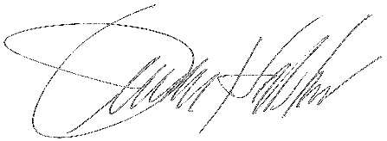
_________________________________
Board Secretary

